**Law in the Aberdeen Council Registers**

**Transcription Manual**

Table of Contents

Introduction 2

How to mark-up text: The importance of white space 2

Orthography 3

Superscript / Subscript 4

Underlining 4

Bold 4

Line breaks 5

punctUATION MARKs in compounds 5

word boundaries 6

paragraphs 7

Divisions 7

Page breaks 9

Word broken up over page breaks 9

Illegible script 10

Uncertain readings 10

Editorial interpolations 11

Apparent Errors 13

Additions 13

Deletions 14

Spaces 15

Marginalia 16

Notes 16

Lists and column breaks 17

Languages 18

Comments 18

Introduction

The aim is to produce a multi-level transcription of volumes 1-8 of the Aberdeen Council Registers. In the first instance a semi-diplomatic transcription will be produced, which will be semi-standardised in a second phase. In the eventual product, it will be possible to turn various annotations on and off according to the user’s needs. The principles set out below are valid for the transcription of Scots, Latin and any other languages appearing in the volumes.

We use Oxygen (an xml editor) and the add-on HisTEI to transcribe our material. We use extensible markup language (xml) according to the specifications of the Text Encoding Initiative (TEI guidelines version P5). TEI provides guidelines as to how texts can be marked up and represented in digital format (see <http://www.tei-c.org/Guidelines/P5/>). Oxygen has a text view where you can insert xml tags to mark things up yourself and an author view, which shows the text in the customized HisTEI view. This HisTEI view resembles a word-processor view, with user friendly buttons and short cut keys. The buttons work the same as in a word processor: select the relevant section, press once and mark-up is applied, press again to undo the mark-up. Behind the scenes your text will be marked up with xml tags, which you can view in the xml text view. Oxygen also prevents you from making errors in the xml code and will validate it (you will see squiggly red lines and the reason for the error when you make a mistake in the Oxygen editor). To learn more about xml, please follow this link: <http://www.w3schools.com/xml/xml_whatis.asp>

Getting started

To start your first transcription, download the template from Google Drive (Technical folder). Open the template in Oxygen and adapt it if necessary. Save your file under a new name before starting your transcription. The file name consists of the xml:id (see section on divisions) from the first entry and the xml:id of the last entry you transcribe, divided by an underscore. The file name will indicate clearly which passages were transcribed because of the following pattern: **ARO-VOL-PAGE-ENTRY_ ARO-VOL-PAGE-ENTRY**. If you, for example, transcribed the first 20 entries of volume 1, the file name would be ARO-1-0001-01_ARO-1-0004-08, i.e. the transcribed text covers all entries from p. 1 up to the eighth entry on p. 4.

How to mark-up text: The importance of white space

As mentioned before, HisTEI resembles word-processing software like Word. It’s easy to use and you’ll figure out quickly how to mark-up text. However, there are a few general rules that have to be observed. Most of these rules are explained below. Before going into detail about particular functions, it should be stressed that white space is very important for the tokenization process. The tokenizer uses white space to recognize orthographic units as words and to mark them up as such. There are a couple of places where **white space should not occur**, as this has consequences for the way text is tokenized:

**Make sure there is no white space between element tags and text, whenever you enclose text with tags within a word.**

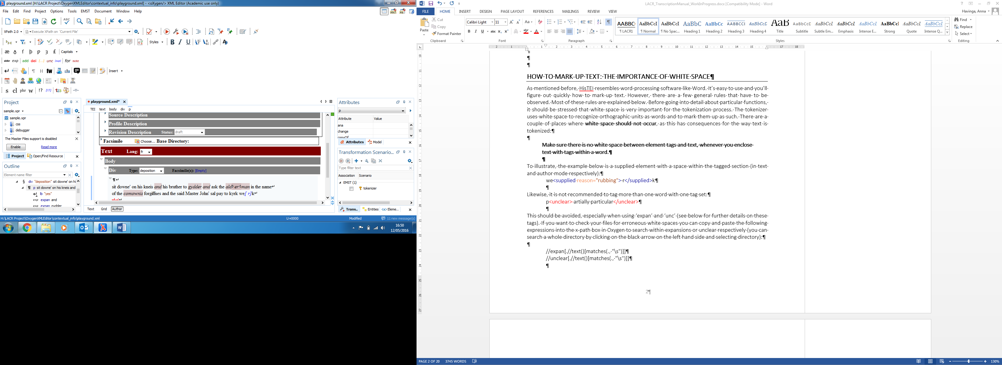To illustrate, the example below is a supplied element with a space within the tagged section (in text and author mode respectively):

we<supplied reason="rubbing"> r</supplied>k

Likewise, it is not recommended to tag more than one word with one tag set:

p<unclear> artially particular</unclear>

This should be avoided, especially when using ‘sup’ and ‘unc’ (see below for further details on these tags). If you want to check your files for erroneous white spaces you can copy and paste the following expressions into the x-path box in Oxygen to search within supplied or unclear elements respectively (you can search a whole directory by clicking on the black arrow on the left hand side and selecting directory):

//supplied[.//text()[matches(., "\s")]]

//unclear[.//text()[matches(., "\s")]]

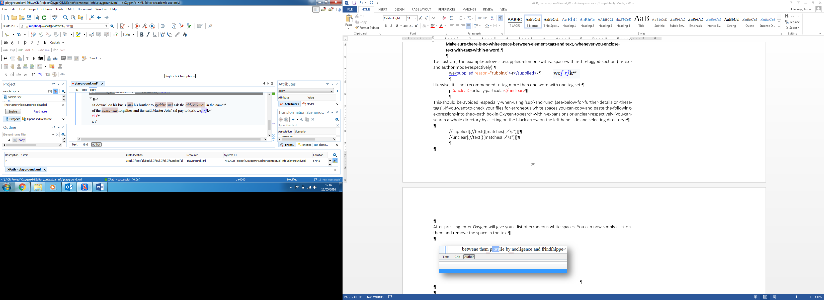

After hitting enter, Oxygen will give you a list of erroneous white spaces. You can now simply click on them and remove the space in the text.

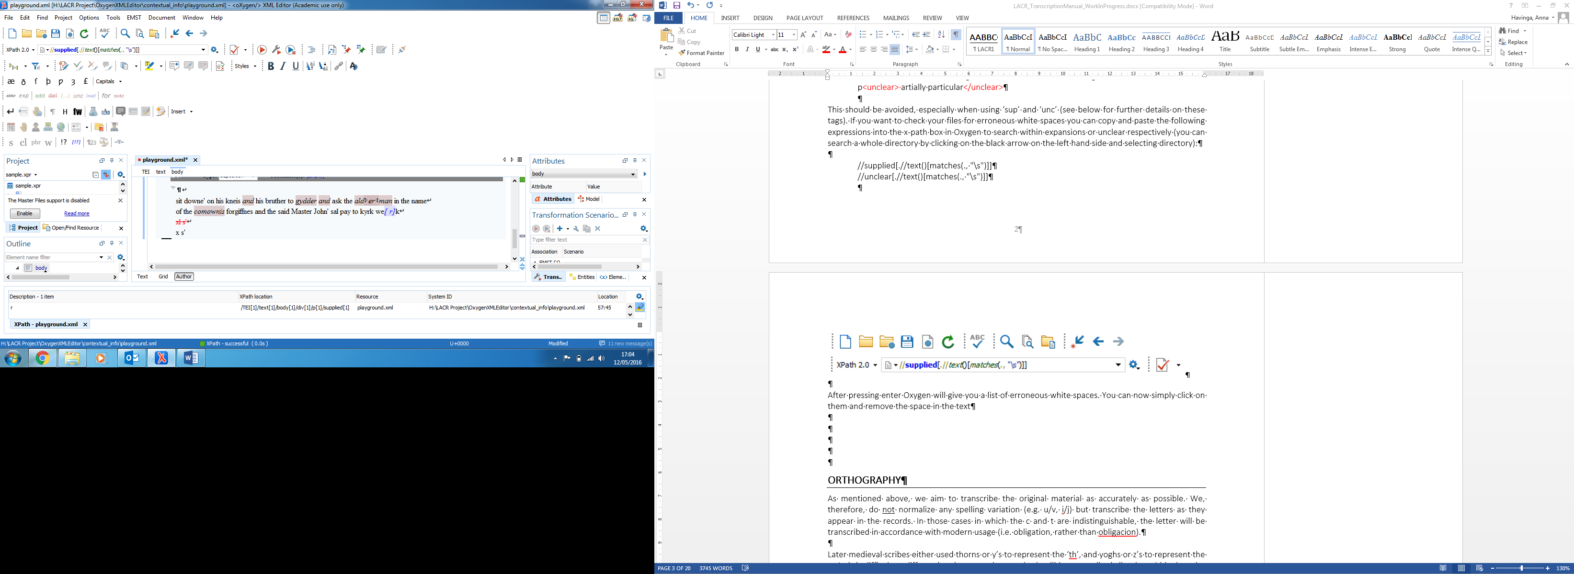

Dates

When referring to dates, they have to be entered in the following format: YYYY-MM-DD. The 30 January 1487 would, for example, be entered as 1487-01-30.

Add screenshot!

Orthography

As mentioned above, we aim to transcribe the original material as accurately as possible. We, therefore, do not normalize any spelling variation (e.g. u/v, i/j) but transcribe the letters as they appear in the records. In those cases **in which the c and t are indistinguishable**, the letter will be transcribed in accordance with modern usage (i.e. obligation, rather than obligacion).

Later medieval scribes either used thorns or y’s to represent the ‘th’, and yoghs or z’s to represent the y. As it is difficult to differentiate between the two, both will be transcribed silently as ‘th’ when the word would have been pronounced with ‘th’, and as ‘y’ when it would have been pronounced as ‘y’. In those cases where the yogh cannot be differentiated from a ‘z’, the context should indicate how to transcribe the letter, for example in the cases of burgez and witnez. The long-s with a curl attached to it (‘scharfes s’) should be transcribed as sis or s’ as the context suggests (or ser when it is referring to a person or is used as a title).

We do not normalize capitalization and punctuation in the first stage of the transcription process. If it is unclear whether a word is uppercase or lowercase, we transcribe it as lowercase in general. However, if the word that is unclear is a name, then we spell it in uppercase. We do not make a distinction between regular capitals and manuscript capitals/decorated initials. However, we add a note when initials are decorated (see section on Notes).

Special punctuation marks, such as < > “ ‘ and &, have to be encoded in xml. HisTEI will encode < and & automatically as &lt; and &amp; if you type them into the author view. The other punctuation marks, however, have to be either encoded manually in the xml text view or added from the entities menu for now. To display the entities window next to the text box, go to Window – Show View – Entities. Double click on the special character to insert it in the text. Alternatively, you can manually type the encoding in the xml text view.

**punctuation mark encoding**

> greater than &gt;

‘ apostrophe &apos;

“ quotation marks &quot;

Superscript / Subscript

We transcribe superscript/subscript for dates and numbers when used in the source text. However, we do not transcribe superscript when abbreviations containing superscript graphs are expanded (see section on Expansions). Use the formats toolbar, or short cut keys:

Short cut key superscript: **ctrl+shift+equals**

Short cut key subscript: **ctrl+ shift+minus**

Tag sets: <hi rend="superscript"></hi>

<hi rend="subscript"></hi>

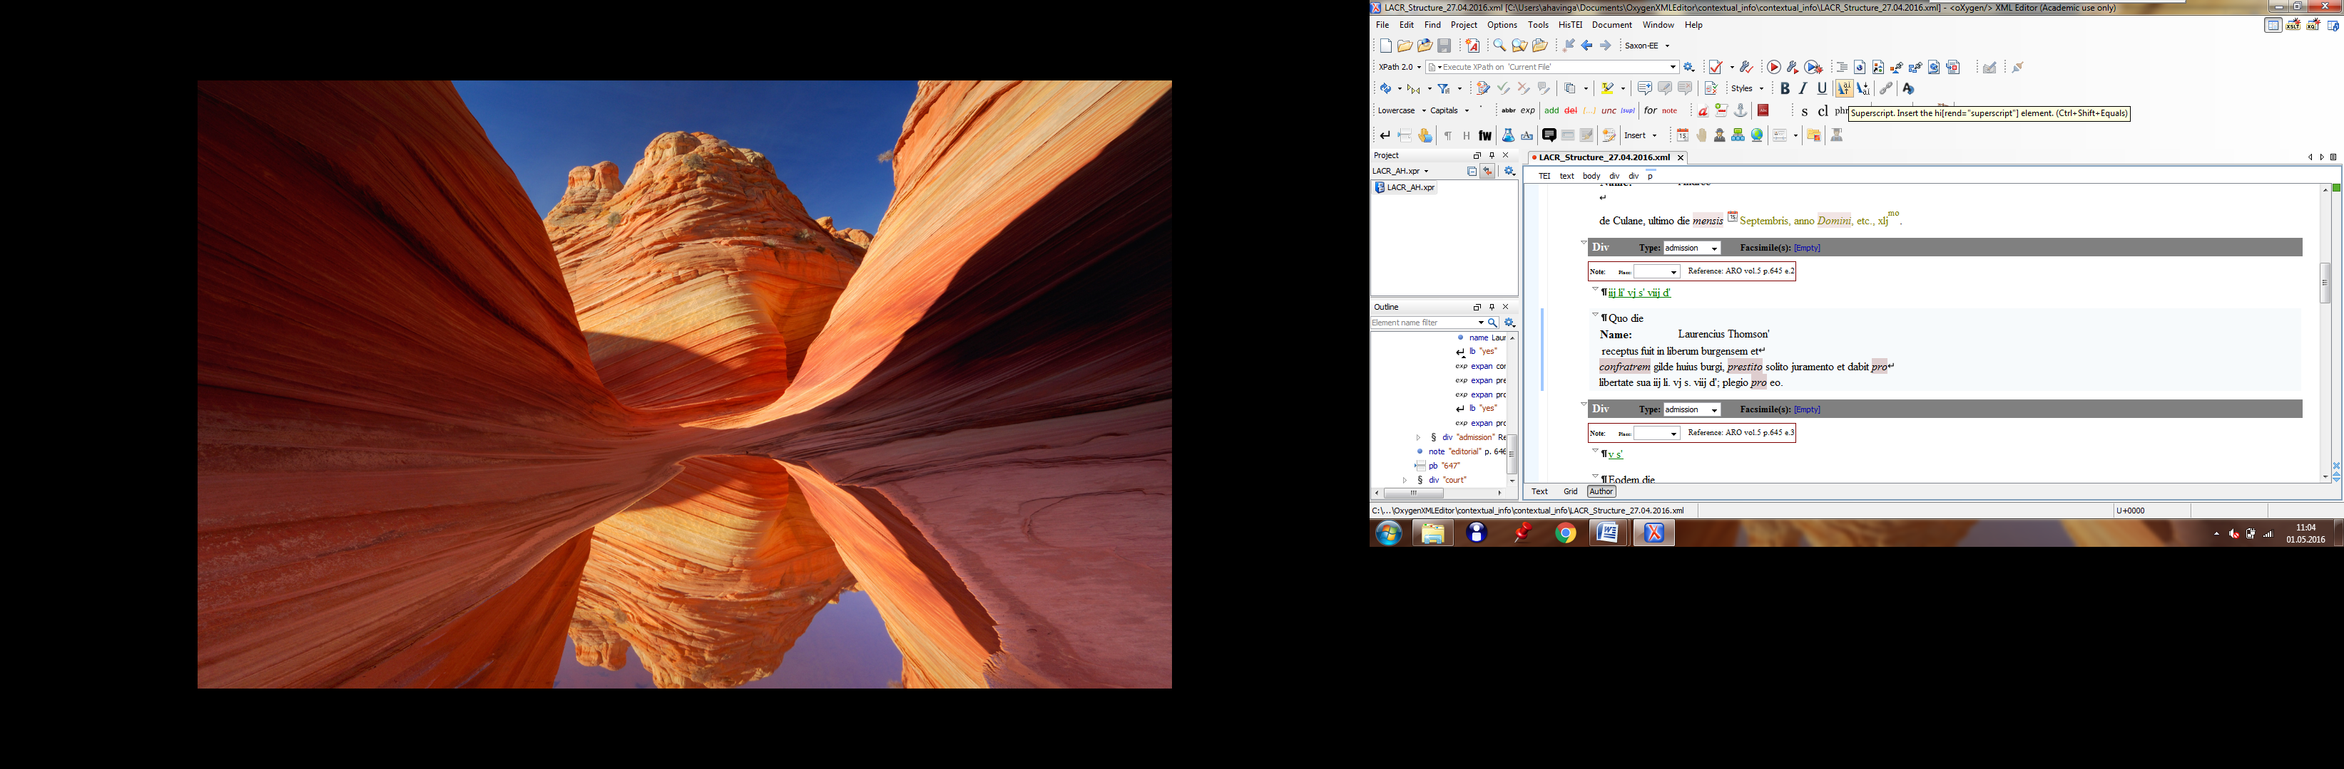

Underlining

Transcribe underlined words when used in the source text. Use the short cut key or button in the formats toolbar (the icon looks the same as in Word).

Short cut keys: **ctrl+U**

Tag set: <hi rend="underline"></hi>

Bold

Transcribe bold words when used in the source text. Use the short cut key or button in the formats toolbar (the icon looks the same as in Word).

Short cut keys: **ctrl+b**

Tag set: <hi rend="bold"></hi>

Line breaks

Line breaks are indicated by pressing the enter key. When the enter key is hit, a box will appear asking whether the break is between words. If so, press the enter key again. If a word is divided due to a line break, change the answer to “no” in the box and then click enter. If a word is split over two lines and marked with a punctuation mark (e.g. a hyphen), you’ll have to add this punctuation mark (see below).

**Important note: a line break should precede the line it marks, so each line has to be preceded by a line break element. In practice this means you will have to start the first line of your transcription with </lb>. In the templates, this is added by default, but just make sure that you start transcribing after the first </lb> element.** **(This is important to make the line numbering correspond with actual lines).**

punctUATION MARKs in compounds

Compounds that are linked with a punctuation mark (usually a hyphen) have to be marked up with a punctuation mark to make sure that they are processed as one token. For compounds that are not linked by a punctuation mark, you will need to use the ‘word’ element (see below).

To add a punctuation mark in a compound use the punctuation button in the annotations toolbar or the short cut key (Ctrl + Alt + P).

Short cut key: **ctrl+shift+P**

Tag set**:** <pc force="weak"></pc>

1. Use the button in annotations toolbar or the short cut key:

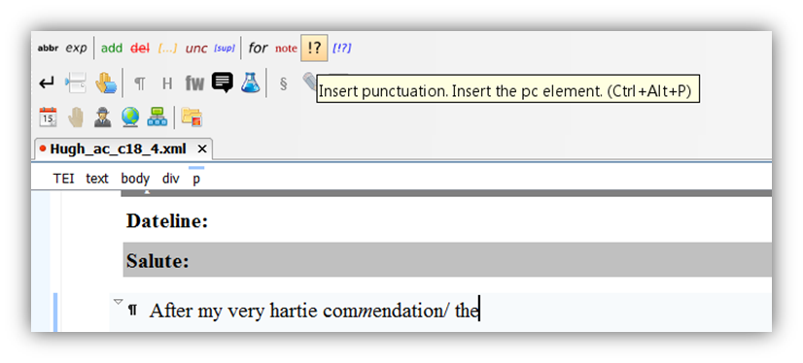

1. Then choose force-weak:

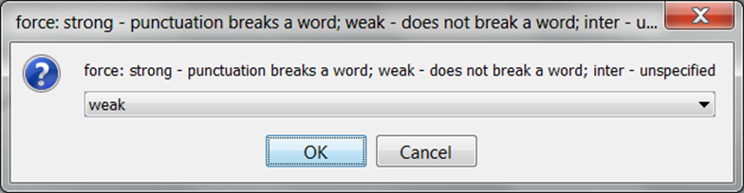

1. Insert relevant punctuation mark (default is a hyphen) and press enter:

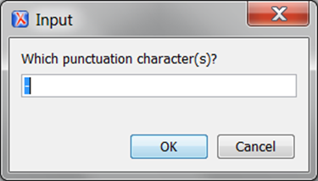

word boundaries

The word boundaries of the texts we transcribe can be different and more variable from present day word boundaries. For instance, *another* is often represented as *a nother*. The aim is to transcribe our texts as faithfully as possible, and thus the original spelling has to be respected in our transcriptions. However, since tokenization depends on white space, it is recommended to mark-up examples like the one above with the ‘word’ element, as this will make the tokenization and the normalization process easier. In the example below the word *overheated* is clearly written as 2 separate words:

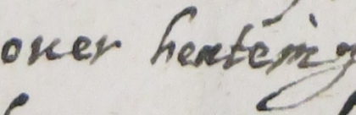

To make sure that it will be tokenized as one word, you have to enclose it with the word element. The two units will then be tokenized as one word while the original white space is maintained. Use the button in the annotations toolbar, or the short cut key:

Short cut key: **ctrl+shift+W**

Tag set: <w></w>

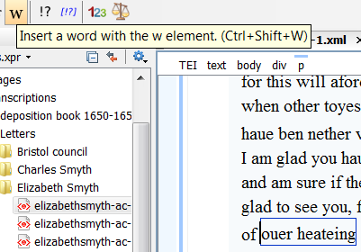

Similarly, two separate words that are spelled together (e.g. havenot) have to be marked-up as two separate words. Select the first word (e.g. have) and press the ‘w’ button, then do the same for the second word (e.g. not). Add an editorial note to say that the word was spelled as one and then separated (see section on Notes).

paragraphs

**Note: when adding a paragraph,** **a line break should precede the line it marks. Each line has to be preceded by a line break element. In practice this means you will have to start the first line of your paragraph with </lb>, i.e. just after <p>.**

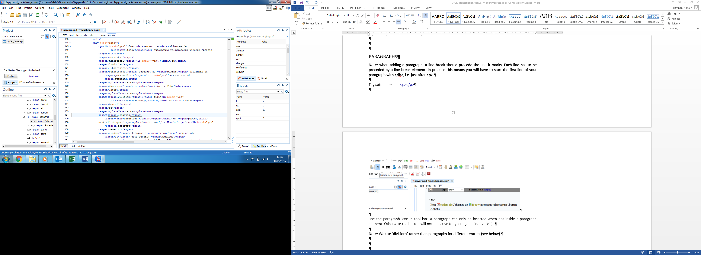

Tag set: <p></p>

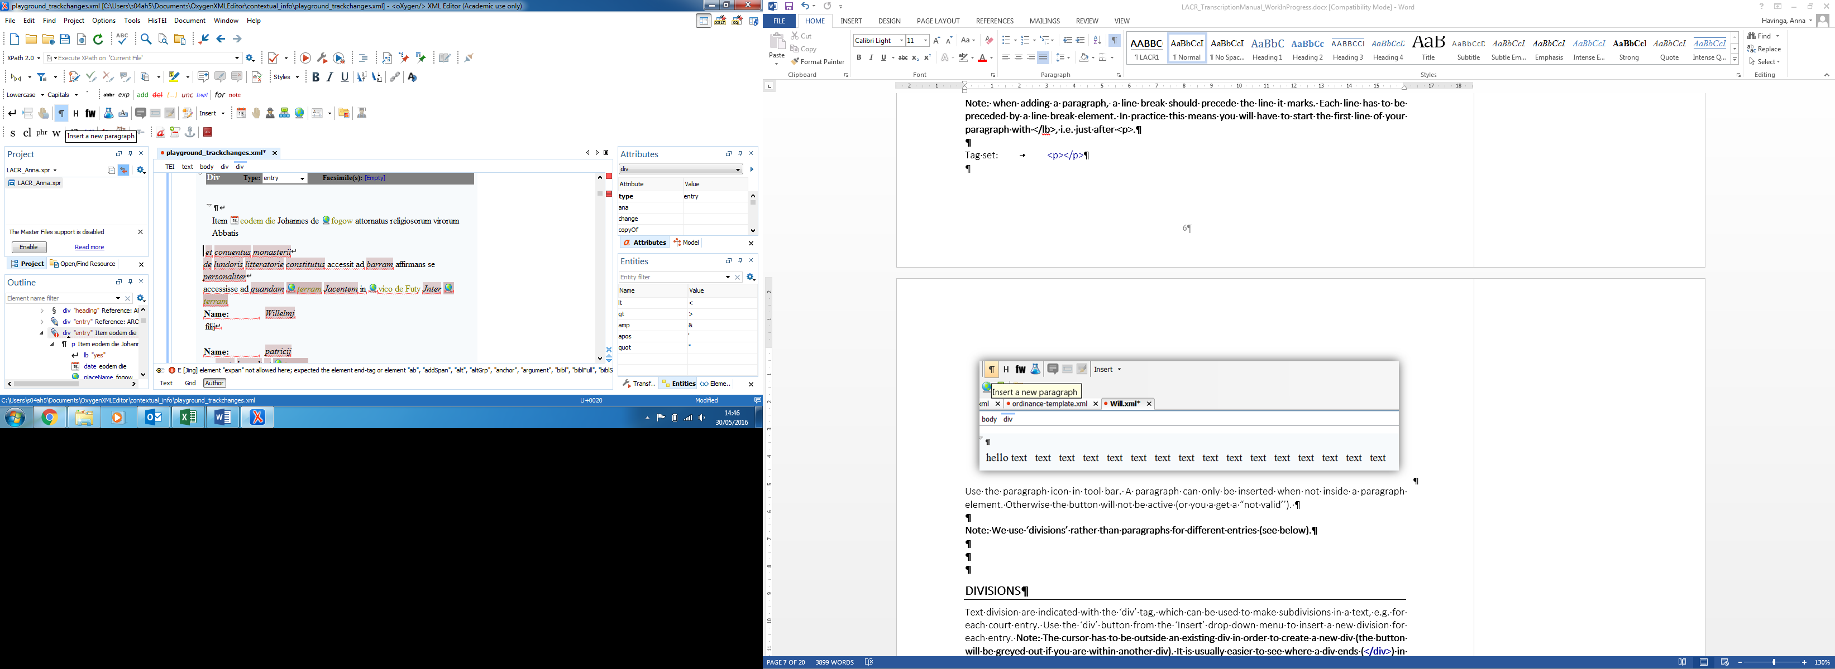

Use the paragraph icon in tool bar. A paragraph can only be inserted when not inside a paragraph element. Otherwise the button will not be active (or you a get a “not valid’’).

**Note: We use ‘divisions’ rather than paragraphs for different entries (see below).**

Divisions

Text division are indicated with the ‘div’ tag, which can be used to make subdivisions in a text, e.g. for each court entry. Use the ‘div’ button from the ‘Insert’ drop-down menu to insert a new division for each entry. **Note: The cursor has to be outside an existing div in order to create a new div (the button will be greyed out if you are within another div). It is usually easier to see where a div ends (</div>) in the xml text view (see screen shot below).**

Tag set: <div></div>

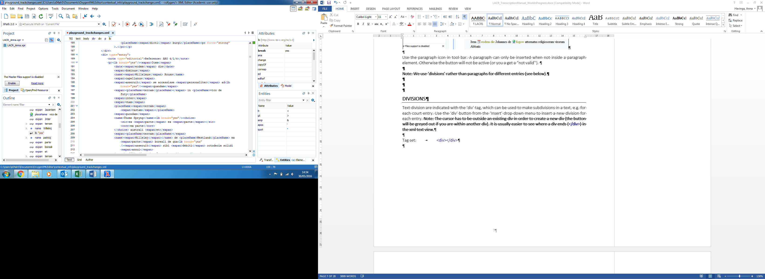

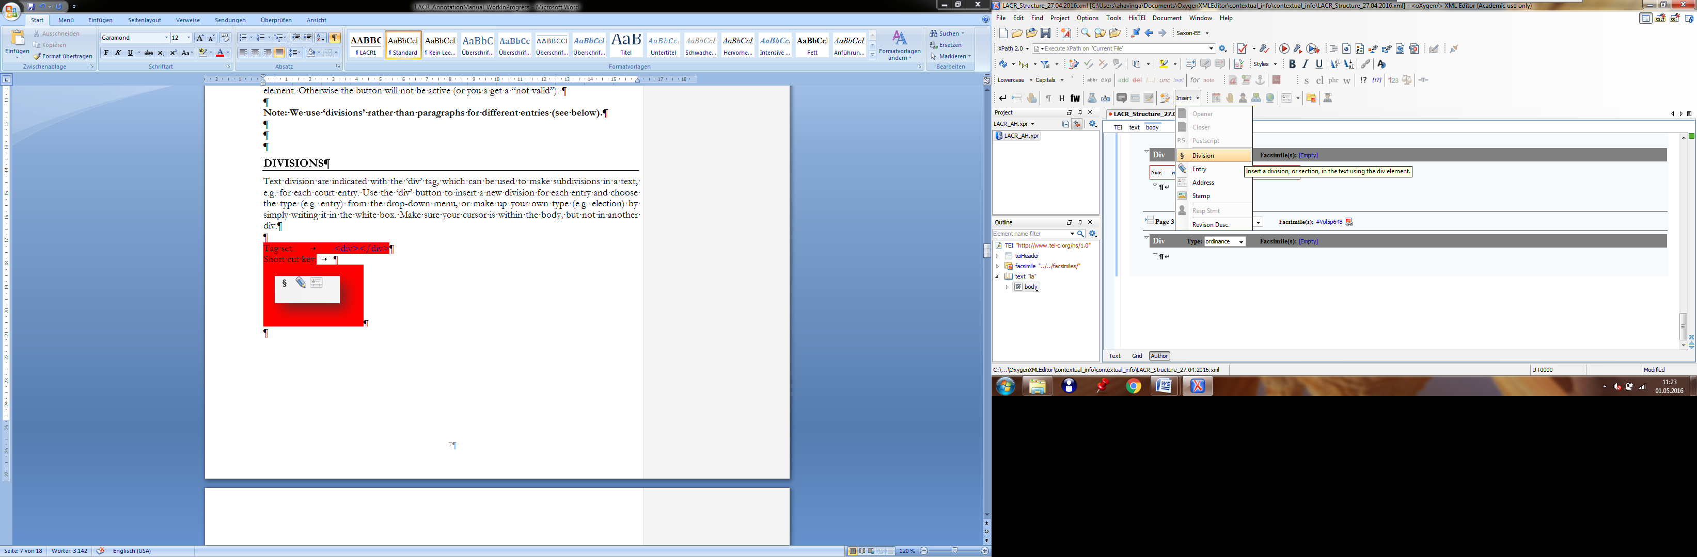

Choose the type (e.g. entry) from the drop-down menu, or make up your own type (e.g. election, ordinance) by simply writing it in the white box.

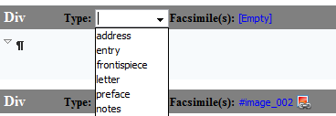

Tag set: <div type=”ordinance”></div>

Each div has a unique xml:id, which you can see and change in the **xml text view**. It follows the following pattern: **ARO-VOL-PAGE-ENTRY**, e.g. ARO-1-0001-01 means that it’s the first entry on the first page of volume 1. We count the entries from the beginning of each page and number them consecutively. Oxygen will warn you with an error message if you’ve used the same xml:id before.

Page breaks

**Note: For each page you transcribe you have to indicate that it is a page by inserting a page break element, even when it is the first page.**

Use the page break element to indicate the page breaks of the original document. In addition to that you have to insert a link to the image of the transcribed page. Add the page number of the original document in the little white box (“n”) between ‘n’ and ‘Facsimiles’. Any additional pages or leaves will be numbered by adding a letter to distinguish it from the previous page (a, b etc), e.g. 198a.

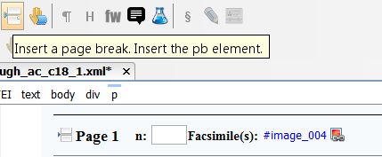

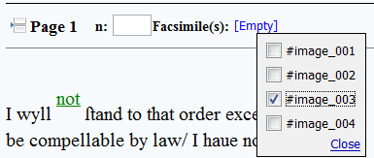

Click on the word highlighted in blue next to facsimile to link the image to the transcription. Check the box of the picture that is transcribed on this page.

**Note: You will have to link images to your file first by inserting a link in the facsimile section (we will set this up at the beginning of the transcription process).**

Word broken up over page breaks

Sometimes you may encounter a word division across page breaks. This has to be indicated. When you insert a page break you will automatically insert the *Break* element as shown below. The default in the box will be ‘yes’, meaning that there is no break between words. When you have a break inside a word you have to choose ‘no’. This way a word that is broken up will still be parsed as one:

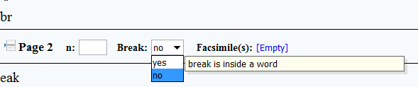

**Note: If the author has used punctuation to break up a word, you will have to mark this up (see section on Punctuation Marks in Compounds above).**

Illegible script

Use the ‘gap’ element when something in the original text is illegible.

Short cut keys: **ctrl+shift+G**

Tag set: <gap reason=”damage”></gap>

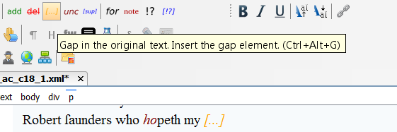

Also the reason for the illegibility should be given and can be chosen from a drop-down menu:

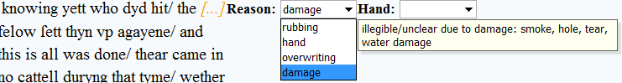

If a whole word is unclear because it has been deleted (e.g. through several strikethroughs), insert a ‘gap’ element and add “deletion” as the reason.

Uncertain readings

When a reading is uncertain, enclose the unclear words/graphs with the ‘unc’ button in the edits toolbar, or use the short cut key.

**Important note: the tag should span no more than one word at a time and there should be no intervening white spaces:**

**So do not do this:** <unclear>word word word</unclear>

**Or this:** <unclear>word w</unclear>ord

**Or this:** <unclear>.word</unclear>

Instead, use the <unclear> function as indicated below:

Tag set: <unclear reason=”hand”>word</unclear>

Short cut key: **ctrl+shift+N**

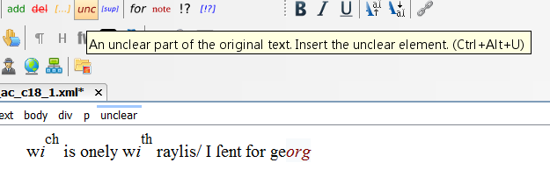

Also indicate why a reading is unclear, by picking one of the options in the dropdown box that will occur when marking the letter(s) as unclear. Do not choose any hand ID.

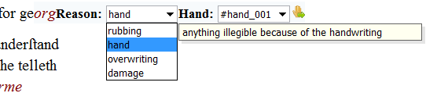

Editorial interpolations

The element ‘supplied’ is used in cases where an item is illegible or missing but it is clear with absolute certainty what should have been there:

Tag set: <supplied></supplied>

Short cut key: **ctrl+shift+L**

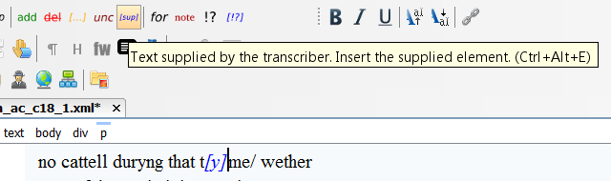

The reason for supplying an item can be picked from a drop-down menu.

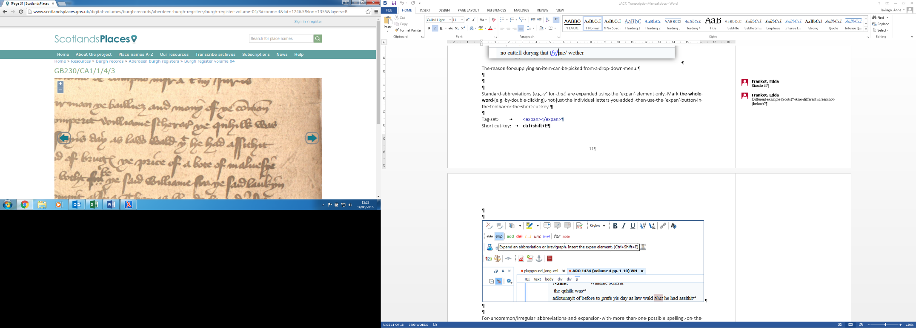

Any abbreviations in Latin are expanded silently. Standard abbreviations in Scots (e.g. for *that*) are expanded using the ‘expan’ element only. Mark **the whole word** (e.g. by double clicking), not just the individual letters you added, then use the ‘expan’ button in the toolbar or the short cut key.

Tag set: <expan></expan>

Short cut key: **ctrl+shift+E**

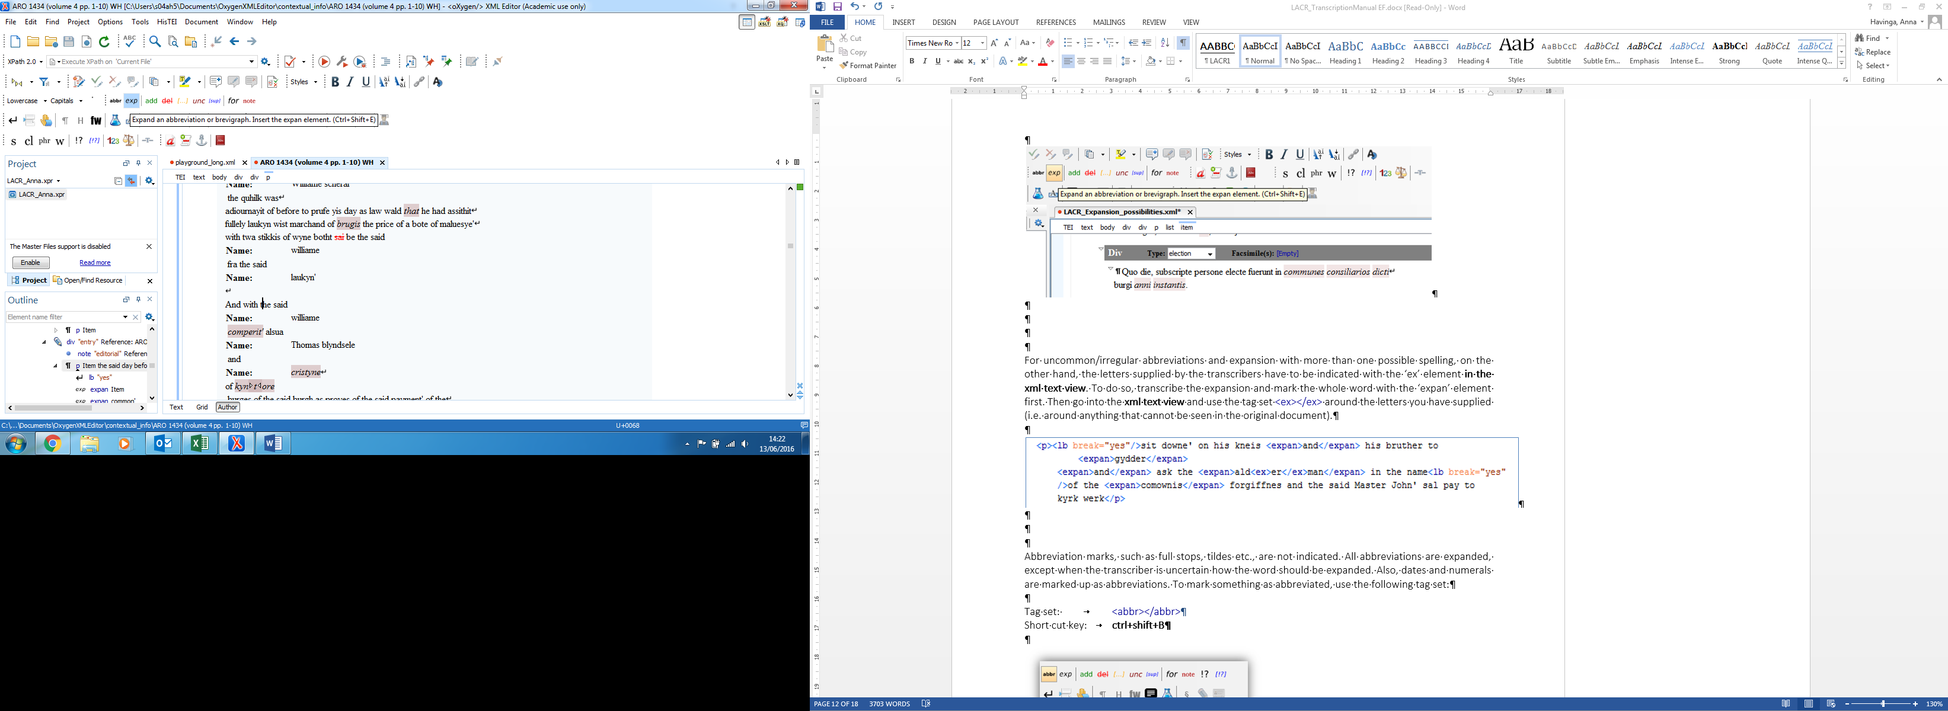

For uncommon/irregular abbreviations and expansion with more than one possible spelling, on the other hand, the letters supplied by the transcribers have to be indicated with the ‘ex’ element **in the xml text view**. To do so, transcribe the expansion and mark the whole word with the ‘expan’ element first. Then go into the **xml text view** and use the tag set <ex></ex> around the letters you have supplied (i.e. around anything that cannot be seen in the original document).

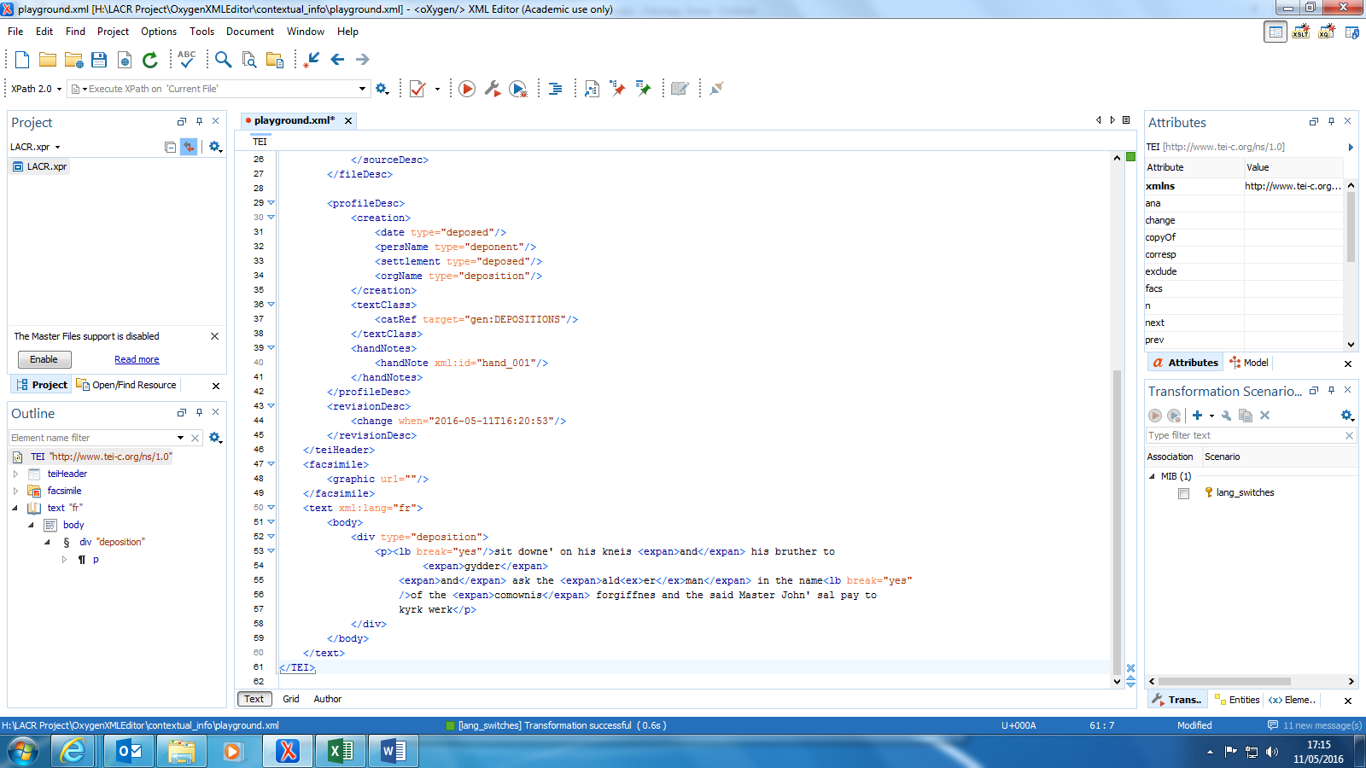

Abbreviation marks, such as full stops, tildes etc., are not indicated. All abbreviations are expanded, except when the transcriber is uncertain how the word should be expanded. To mark something as abbreviated, use the following tag set:

Tag set: <abbr></abbr>

Short cut key: **ctrl+shift+B**

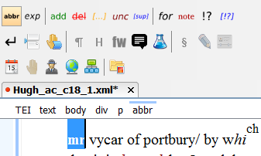

In cases in which there is an abbreviation mark or flourish, but the word already appears to be complete (or is understandable without any further additions, such as *hous’*, *becaus’* etc.), an apostrophe is added at the end of the word but the word is not marked up as an ‘abbreviation’. Where the nature of the intended expansion is doubtful, an apostrophe will also be used and the word is annotated as an ‘abbreviation’.

Abbreviated currencies will not be expanded. The existing letters will be followed by an apostrophe to indicate the abbreviation mark, and annotated as ‘abbreviation’. Complete words, including those with minor contractions or suspensions, are transcribed in full.

Dates will be represented as they are written in the original, as these often combine numbers and letters. Superscripted letters will not be lowered but marked up as superscripted (see section on super-/subscript above) and abbreviations not expanded. For example, xxjmo die Octobris; anno Domini xliiijto. Numbers, generally Roman numerals, will be represented as they are written in the original.

Apparent Errors

Apparent errors will be annotated with ‘sic’, and the correction supplied with ‘corr’. For now, there are no buttons in the HisTEI author view for these elements, which means that you have to go to the **xml text view** to mark up these cases. We use a ‘choice’ element around both mark-ups.

Tag set: <choice><sic></sic><corr></corr></choice>

Example: John' sal pay to <choice><sic>kryk</sic><corr>kyrk</corr></choice> werk

Additions

Use the ‘addition’ element when the author has inserted text, e.g. something has been deleted and a new word has been inserted between the lines, or a word has been written and a missing letter is inserted between lines. We also indicate the place where the text was inserted: above, below, margin (right/left) etc. Use the ‘add’ button in the edits toolbar or the short cut key.

Tag set: <add place=""></add>

Short cut key: **ctrl+shift+A**

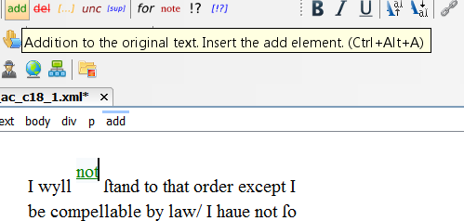

The place of the addition has to be selected in the dropdown menu. Do not select any hand ID.

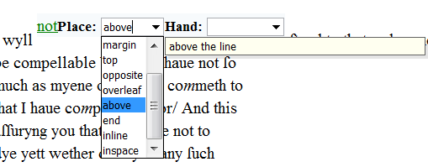

Deletions

Use the ‘deletion’ element (the ‘del’ button in the edits toolbar or the short cut key) when an author has deleted text.

Tag set: <del></del>

Short cut key: **ctrl+shift+D**

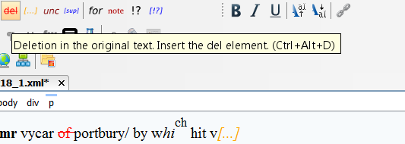

When the deleted part is unclear or illegible, it can contain the elements <unclear>, <gap> and <supplied>. It can thus look as follows:

When the deleted reading is uncertain, insert the unclear tag with the ‘unc’ button:

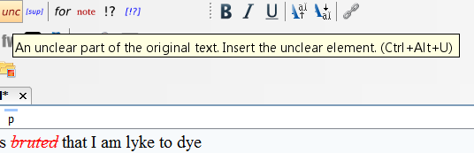

When a part of the deletion is illegible, insert the gap element with ‘gap’ button:

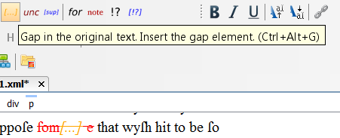

**Note: When the whole word cannot be read due to the deletion, insert the ‘gap’ element only and give “deletion” as the reason. Do not add the deletion element as well.**

In accounts, any items that are struck through as a result of payment of the amount will also be represented as deleted, but its special status indicated in the annotation by using the ‘type’ element. Mark the amount as deleted first by using the ‘del’ button as described above. Then go into the **xml text view** to add that the ‘type’ of the deletion is “paid”.

Tag set: <del type="paid"></del>

Example: <del type="paid">xl s'</del>

This addition will not change anything in the HisTEI author view, i.e. the items will just be struck through.

Spaces

Indicate any unusual spaces in the source text, e.g. space left for a word or entry to be filled in later, with the ‘space’ element. You will also need to indicate the extent of the space. To do so, go to the **xml text view** and insert the following tag:

Tag: <space/>

Expand this tag with information about the extent of the space.

e.g. <space quantity=”3” unit=”words”/>

<space quantity=”2” unit=”lines”/>

<space quantity=”1” unit=”paragraphs”/>

Marginalia

The majority of marginalia appears in the form of a catchword or catchwords for an entry, either consisting of a name, or names, or of a description of the type of entry (for example: protestatio, inquisitio).

Marginalia are marked up with the ‘add’ element, selecting “margin” as the place of the edition (see section on Additions).

Tag set: <add place="margin"></add>

Short cut key: **ctrl+shift+A**

After marking the text as an addition in the margin, select the text and mark it as a ‘heading’, using the button in the toolbar menu. Select ‘sub’ as the type of heading.

Tag set: <head type=”sub”></head>

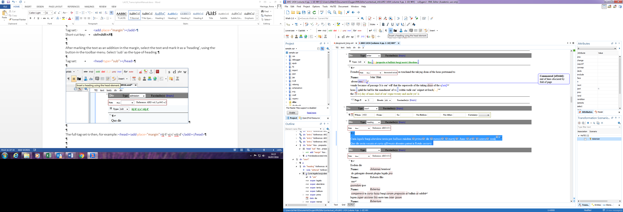

The full tag set is then, for example: <head><add place="margin">iij li' vj s' viij d'</add></head>

Notes

Use the element ‘note’ for annotations e.g. text added at some later point in time that comments on the text (rather than that it is a word that was missing and inserted, as this would be an addition):

Tag set : <note anchored="false" place="margin"></note>

Short cut key: **ctrl+shift+O**

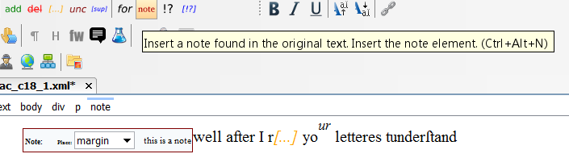

Notes can also be used for editorial purposes (ignore the specific description in HisTEI), e.g. to describe decorated initials, drawings, pointing hands, signatures, complicated layout and missing/empty pages. For editorial notes, go into the **xml text view** and use the following tag set:

Tag set: <note type=”editorial”></note>

Example: <note type=”editorial”>Page 564 is empty</note>

Lists and column breaks

Any lists should initially only be indicated with column breaks. To add a column break, go into the **xml text view** and enter the tag <cb/>. Also indicate the number of the column within this tag:

Tag: <cb n=”1”/> (replace 1 with the appropriate number for further columns)

Go back into author view, to add the items of the list. Separate them with line breaks.

Author view:

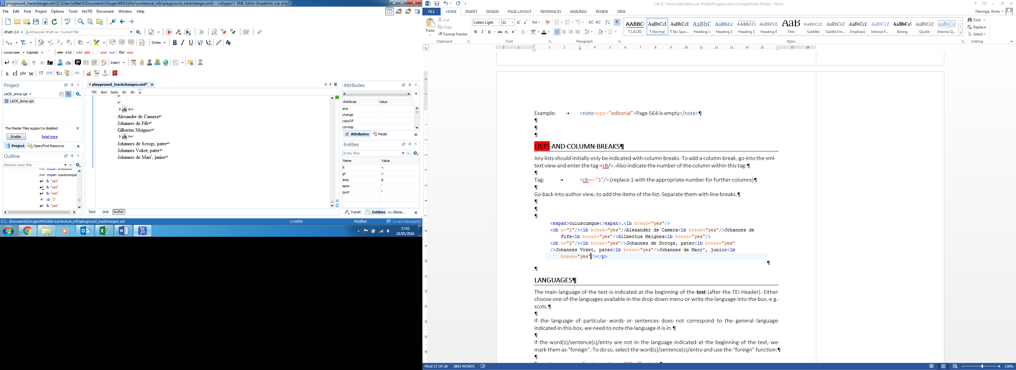

Xml text view:

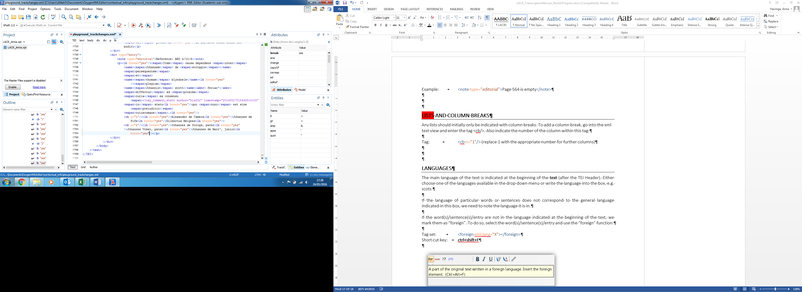

Languages

We indicate the language of each entry on the div level. To choose a language, double-click on the div tag, select xml:lang as the name and either choose one of the languages available in the drop-down menu or write the language into the value box, e.g. **“sc” for Scots, “la” for Latin**. If you can’t establish a single language for a particular entry you can use the value **“mul” for multiple languages**.

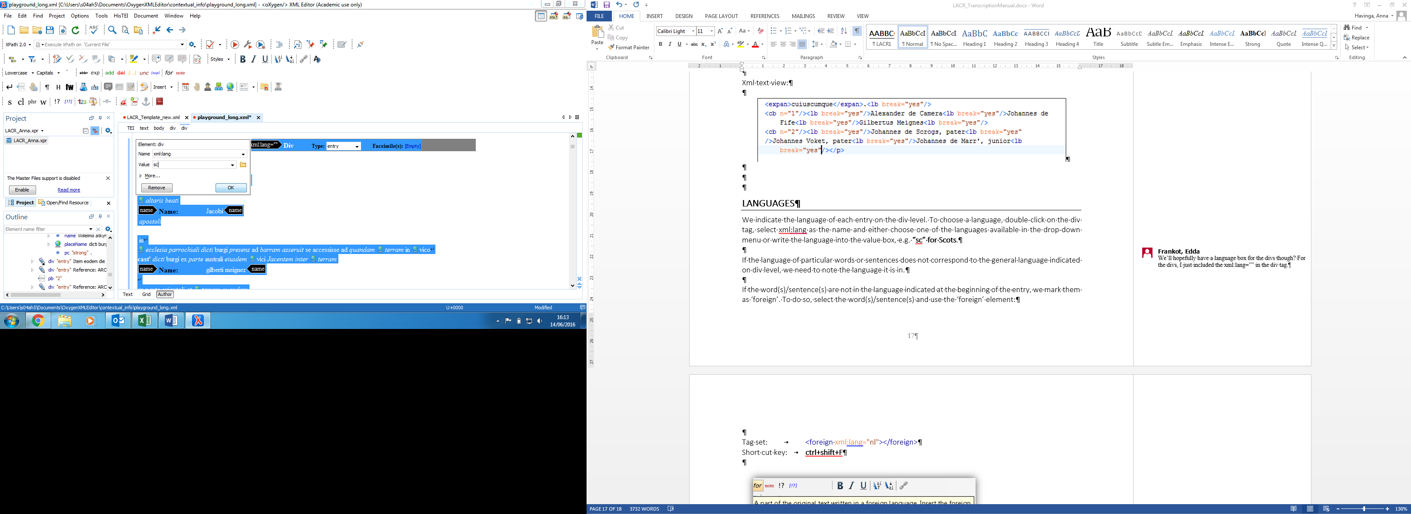

If the language of particular words or sentences does not correspond to the general language indicated on div level, we need to note the language it is in.

If the word(s)/sentence(s) are not in the language indicated at the beginning of the entry, we mark them as ‘foreign’. To do so, select the word(s)/sentence(s) and use the ‘foreign’ element:

Tag set: <foreign xml:lang="nl"></foreign>

Short cut key: **ctrl+shift+F**

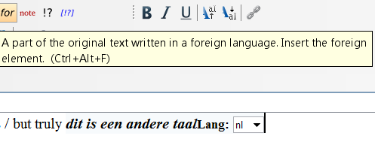

Select the ‘foreign’ language in the dropdown menu. If the language is not listed, write it in the box. **Note: You need to mark-up ‘foreign’ elements before adding any further annotations (e.g. expansion, abbreviation, supplied etc.). Alternatively, add the ‘foreign’ element in the xml text view (see tag set above).**

Comments

Use the ‘comment’ element for editorial comments, to indicate, for example, that something is unclear or needs to be checked. Comments are for project-internal communication only. They will be deleted as soon as they are dealt with.

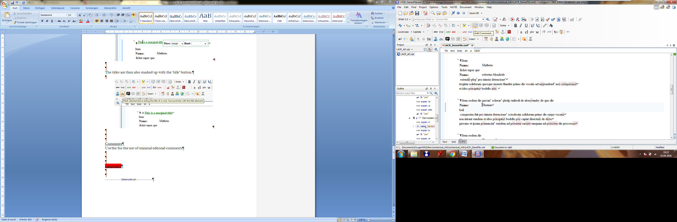

There are further editorial functions available in HisTEI (see ‘track changes’ button). However, they are sometimes tricky to use or don’t work properly. It is, therefore, best to stick with the comments button for suggestions and questions.